Downloading...
From: https://drive.google.com/uc?id=1VJaDVtDUtKQMmhRAqr3t-fgng899ZdRV
To: /content/Python Application Usage Log Data Set.xlsx
100%|██████████| 1.68M/1.68M [00:00<00:00, 76.7MB/s]
DEBUG:cmdstanpy:input tempfile: /tmp/tmp33xtk85n/fj8m8cu0.json
DEBUG:cmdstanpy:input tempfile: /tmp/tmp33xtk85n/r_ubx8h5.json
DEBUG:cmdstanpy:idx 0
DEBUG:cmdstanpy:running CmdStan, num_threads: None
DEBUG:cmdstanpy:CmdStan args: ['/usr/local/lib/python3.12/dist-packages/prophet/stan_model/prophet_model.bin', 'random', 'seed=18061', 'data', 'file=/tmp/tmp33xtk85n/fj8m8cu0.json', 'init=/tmp/tmp33xtk85n/r_ubx8h5.json', 'output', 'file=/tmp/tmp33xtk85n/prophet_model9j_zsyup/prophet_model-20251025084658.csv', 'method=optimize', 'algorithm=lbfgs', 'iter=10000']
08:46:58 - cmdstanpy - INFO - Chain [1] start processing
INFO:cmdstanpy:Chain [1] start processing
08:47:07 - cmdstanpy - INFO - Chain [1] done processing
INFO:cmdstanpy:Chain [1] done processing
DEBUG:cmdstanpy:input tempfile: /tmp/tmp33xtk85n/fxqnkkd7.json
DEBUG:cmdstanpy:input tempfile: /tmp/tmp33xtk85n/sh12k__u.json
DEBUG:cmdstanpy:idx 0
DEBUG:cmdstanpy:running CmdStan, num_threads: None
DEBUG:cmdstanpy:CmdStan args: ['/usr/local/lib/python3.12/dist-packages/prophet/stan_model/prophet_model.bin', 'random', 'seed=68152', 'data', 'file=/tmp/tmp33xtk85n/fxqnkkd7.json', 'init=/tmp/tmp33xtk85n/sh12k__u.json', 'output', 'file=/tmp/tmp33xtk85n/prophet_modelj452fsga/prophet_model-20251025084708.csv', 'method=optimize', 'algorithm=lbfgs', 'iter=10000']
08:47:08 - cmdstanpy - INFO - Chain [1] start processing
INFO:cmdstanpy:Chain [1] start processing
08:47:15 - cmdstanpy - INFO - Chain [1] done processing
INFO:cmdstanpy:Chain [1] done processing
DEBUG:cmdstanpy:input tempfile: /tmp/tmp33xtk85n/9tfix65l.json
DEBUG:cmdstanpy:input tempfile: /tmp/tmp33xtk85n/z6c4pd85.json
DEBUG:cmdstanpy:idx 0
DEBUG:cmdstanpy:running CmdStan, num_threads: None
DEBUG:cmdstanpy:CmdStan args: ['/usr/local/lib/python3.12/dist-packages/prophet/stan_model/prophet_model.bin', 'random', 'seed=47139', 'data', 'file=/tmp/tmp33xtk85n/9tfix65l.json', 'init=/tmp/tmp33xtk85n/z6c4pd85.json', 'output', 'file=/tmp/tmp33xtk85n/prophet_modelh3mvxkc8/prophet_model-20251025084716.csv', 'method=optimize', 'algorithm=lbfgs', 'iter=10000']
08:47:16 - cmdstanpy - INFO - Chain [1] start processing
INFO:cmdstanpy:Chain [1] start processing
08:47:23 - cmdstanpy - INFO - Chain [1] done processing
INFO:cmdstanpy:Chain [1] done processing
DEBUG:cmdstanpy:input tempfile: /tmp/tmp33xtk85n/smmri79f.json
DEBUG:cmdstanpy:input tempfile: /tmp/tmp33xtk85n/5mcvd03s.json
DEBUG:cmdstanpy:idx 0
DEBUG:cmdstanpy:running CmdStan, num_threads: None
DEBUG:cmdstanpy:CmdStan args: ['/usr/local/lib/python3.12/dist-packages/prophet/stan_model/prophet_model.bin', 'random', 'seed=78107', 'data', 'file=/tmp/tmp33xtk85n/smmri79f.json', 'init=/tmp/tmp33xtk85n/5mcvd03s.json', 'output', 'file=/tmp/tmp33xtk85n/prophet_modeln3naemjb/prophet_model-20251025084724.csv', 'method=optimize', 'algorithm=lbfgs', 'iter=10000']
08:47:24 - cmdstanpy - INFO - Chain [1] start processing
INFO:cmdstanpy:Chain [1] start processing
08:47:30 - cmdstanpy - INFO - Chain [1] done processing
INFO:cmdstanpy:Chain [1] done processing
DEBUG:cmdstanpy:input tempfile: /tmp/tmp33xtk85n/7u01hbcv.json
DEBUG:cmdstanpy:input tempfile: /tmp/tmp33xtk85n/ynq_uayh.json
DEBUG:cmdstanpy:idx 0
DEBUG:cmdstanpy:running CmdStan, num_threads: None
DEBUG:cmdstanpy:CmdStan args: ['/usr/local/lib/python3.12/dist-packages/prophet/stan_model/prophet_model.bin', 'random', 'seed=86888', 'data', 'file=/tmp/tmp33xtk85n/7u01hbcv.json', 'init=/tmp/tmp33xtk85n/ynq_uayh.json', 'output', 'file=/tmp/tmp33xtk85n/prophet_modeltqg0hzam/prophet_model-20251025084731.csv', 'method=optimize', 'algorithm=lbfgs', 'iter=10000']
08:47:31 - cmdstanpy - INFO - Chain [1] start processing
INFO:cmdstanpy:Chain [1] start processing
08:47:37 - cmdstanpy - INFO - Chain [1] done processing
INFO:cmdstanpy:Chain [1] done processing
DEBUG:cmdstanpy:input tempfile: /tmp/tmp33xtk85n/csdmtvjv.json
DEBUG:cmdstanpy:input tempfile: /tmp/tmp33xtk85n/hlssqtd2.json
DEBUG:cmdstanpy:idx 0
DEBUG:cmdstanpy:running CmdStan, num_threads: None
DEBUG:cmdstanpy:CmdStan args: ['/usr/local/lib/python3.12/dist-packages/prophet/stan_model/prophet_model.bin', 'random', 'seed=23760', 'data', 'file=/tmp/tmp33xtk85n/csdmtvjv.json', 'init=/tmp/tmp33xtk85n/hlssqtd2.json', 'output', 'file=/tmp/tmp33xtk85n/prophet_modelazw0zpz_/prophet_model-20251025084738.csv', 'method=optimize', 'algorithm=lbfgs', 'iter=10000']
08:47:38 - cmdstanpy - INFO - Chain [1] start processing
INFO:cmdstanpy:Chain [1] start processing
08:47:42 - cmdstanpy - INFO - Chain [1] done processing
INFO:cmdstanpy:Chain [1] done processing
DEBUG:cmdstanpy:input tempfile: /tmp/tmp33xtk85n/8c2uc49h.json
DEBUG:cmdstanpy:input tempfile: /tmp/tmp33xtk85n/4bhappr8.json
DEBUG:cmdstanpy:idx 0
DEBUG:cmdstanpy:running CmdStan, num_threads: None
DEBUG:cmdstanpy:CmdStan args: ['/usr/local/lib/python3.12/dist-packages/prophet/stan_model/prophet_model.bin', 'random', 'seed=15705', 'data', 'file=/tmp/tmp33xtk85n/8c2uc49h.json', 'init=/tmp/tmp33xtk85n/4bhappr8.json', 'output', 'file=/tmp/tmp33xtk85n/prophet_modelpp_hy5q5/prophet_model-20251025084743.csv', 'method=optimize', 'algorithm=lbfgs', 'iter=10000']
08:47:43 - cmdstanpy - INFO - Chain [1] start processing
INFO:cmdstanpy:Chain [1] start processing
08:47:48 - cmdstanpy - INFO - Chain [1] done processing
INFO:cmdstanpy:Chain [1] done processing
DEBUG:cmdstanpy:input tempfile: /tmp/tmp33xtk85n/hh4qmoqa.json
DEBUG:cmdstanpy:input tempfile: /tmp/tmp33xtk85n/tv35a7zt.json
DEBUG:cmdstanpy:idx 0
DEBUG:cmdstanpy:running CmdStan, num_threads: None
DEBUG:cmdstanpy:CmdStan args: ['/usr/local/lib/python3.12/dist-packages/prophet/stan_model/prophet_model.bin', 'random', 'seed=85281', 'data', 'file=/tmp/tmp33xtk85n/hh4qmoqa.json', 'init=/tmp/tmp33xtk85n/tv35a7zt.json', 'output', 'file=/tmp/tmp33xtk85n/prophet_model60z7_71n/prophet_model-20251025084749.csv', 'method=optimize', 'algorithm=lbfgs', 'iter=10000']
08:47:49 - cmdstanpy - INFO - Chain [1] start processing
INFO:cmdstanpy:Chain [1] start processing
08:47:52 - cmdstanpy - INFO - Chain [1] done processing
INFO:cmdstanpy:Chain [1] done processing
DEBUG:cmdstanpy:input tempfile: /tmp/tmp33xtk85n/8nry02dy.json
DEBUG:cmdstanpy:input tempfile: /tmp/tmp33xtk85n/cqycdh_4.json
DEBUG:cmdstanpy:idx 0
DEBUG:cmdstanpy:running CmdStan, num_threads: None
DEBUG:cmdstanpy:CmdStan args: ['/usr/local/lib/python3.12/dist-packages/prophet/stan_model/prophet_model.bin', 'random', 'seed=80610', 'data', 'file=/tmp/tmp33xtk85n/8nry02dy.json', 'init=/tmp/tmp33xtk85n/cqycdh_4.json', 'output', 'file=/tmp/tmp33xtk85n/prophet_modelbqtwwhfu/prophet_model-20251025084753.csv', 'method=optimize', 'algorithm=lbfgs', 'iter=10000']
08:47:53 - cmdstanpy - INFO - Chain [1] start processing
INFO:cmdstanpy:Chain [1] start processing
08:47:57 - cmdstanpy - INFO - Chain [1] done processing
INFO:cmdstanpy:Chain [1] done processing
DEBUG:cmdstanpy:input tempfile: /tmp/tmp33xtk85n/1yqsoh08.json
DEBUG:cmdstanpy:input tempfile: /tmp/tmp33xtk85n/urhyfuip.json
DEBUG:cmdstanpy:idx 0
DEBUG:cmdstanpy:running CmdStan, num_threads: None
DEBUG:cmdstanpy:CmdStan args: ['/usr/local/lib/python3.12/dist-packages/prophet/stan_model/prophet_model.bin', 'random', 'seed=28022', 'data', 'file=/tmp/tmp33xtk85n/1yqsoh08.json', 'init=/tmp/tmp33xtk85n/urhyfuip.json', 'output', 'file=/tmp/tmp33xtk85n/prophet_modelpn5ovjev/prophet_model-20251025084757.csv', 'method=optimize', 'algorithm=lbfgs', 'iter=10000']
08:47:57 - cmdstanpy - INFO - Chain [1] start processing
INFO:cmdstanpy:Chain [1] start processing
08:48:02 - cmdstanpy - INFO - Chain [1] done processing
INFO:cmdstanpy:Chain [1] done processing
Best Prophet: {'changepoint_prior_scale': 0.8, 'seasonality_mode': 'multiplicative'} | Best LSTM: {'units': 64, 'dropout': 0.2, 'window': 21} (val_loss=0.1043)

HOLDOUT (28d) — MAE: 404.71 | RMSE: 531.33 | MAPE: 9.44% | Accuracy: 90.56%
Prophet-only HOLDOUT MAPE: 10.27% → ΔMAPE vs Hybrid: +0.83 pts

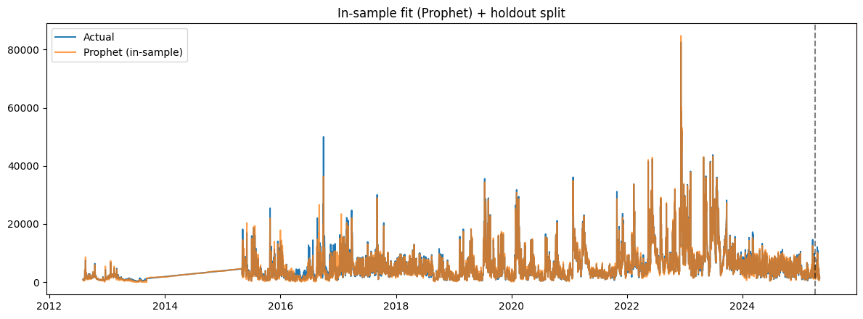
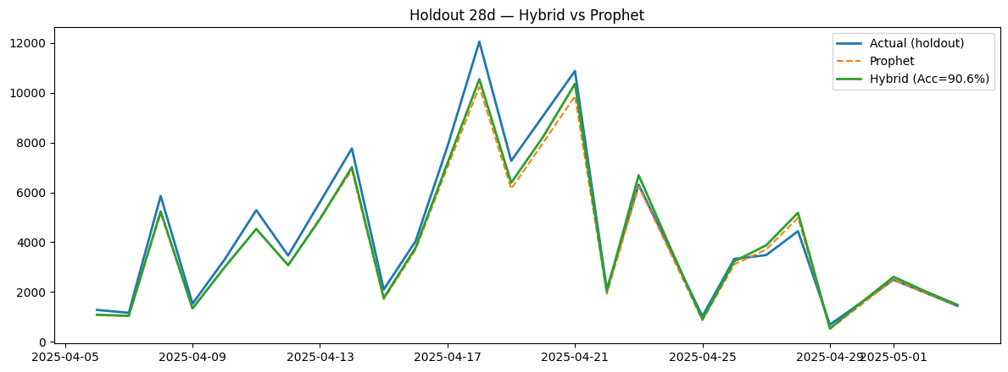
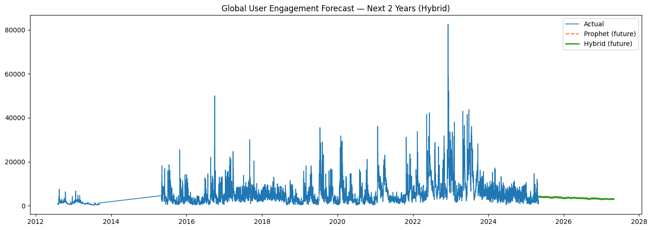
WARNING:absl:You are saving your model as an HDF5 file via `model.save()` or `keras.saving.save_model(model)`. This file format is considered legacy. We recommend using instead the native Keras format, e.g. `model.save('my_model.keras')` or `keras.saving.save_model(model, 'my_model.keras')`.

Artifacts saved to: /content/hybrid_97acc_artifacts
- 2year_forecast.csv
- lstm_residual.h5
- metrics.json
- prophet_global.json
- x_scaler.npy
- y_scaler.npy

Checkpoints saved to: /content/v3_ultrafast_ckpts
- lstm_best_win21.keras
- lstm_residual_final.keras

